SPRINT 1

|  |  |
| --- | --- |
| TEAM ID | PNT2022TMID44628 |
| PROJECT NAME | CHILD MONITORING AND ALERTING SYSTEM |

ARDUINO UNO WITH SENSOR:

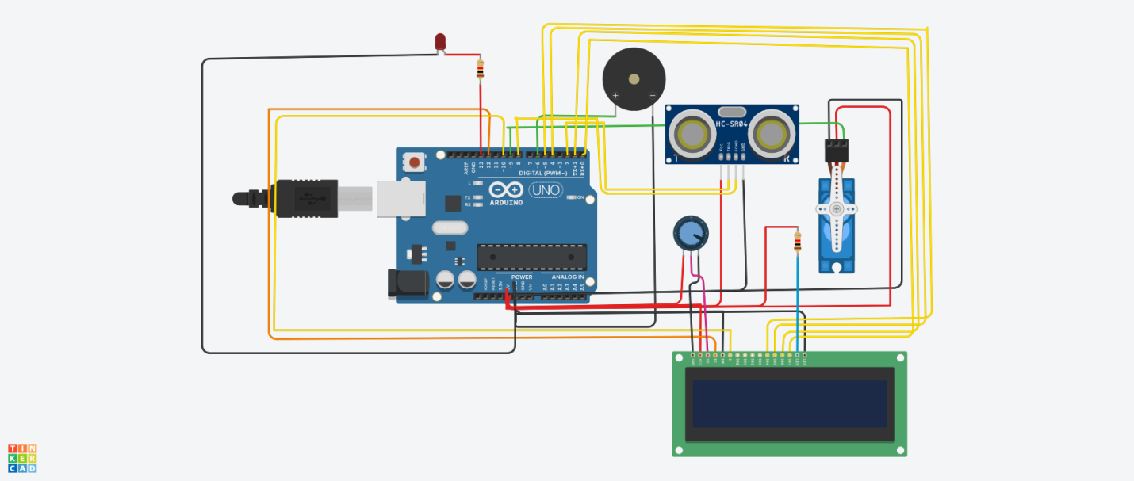

IN THE ABOVE CIRCUIT WE CONNECT THE ARDUINO UNO WITH SENSORS, BUZZER.

PROGRAM

#include<Servo.h>

#include<LiquidCrystal.h>

Servo servo_9;

LiquidCrystal lcd(12,10,5,4,1,0);

int distance;

int pos;

void setup()

{

servo_9.attach(9);

lcd.begin(16,2);

pinMode(2, OUTPUT);

pinMode(8,INPUT);

pinMode(5,OUTPUT);

pinMode(6,OUTPUT);

pinMode(13,OUTPUT);

}

void loop()

{

digitalWrite(2,LOW);

delayMicroseconds(2);

digitalWrite(2,HIGH);

delayMicroseconds(10);

digitalWrite(2,LOW);

distance=pulseIn(3,HIGH)*0.017;

if (distance=18){

lcd.print("Distance equals");

lcd.setCursor(0,1);

lcd.print(distance);

digitalWrite(13,HIGH);

for (pos=0; pos<=72; pos+=1){

servo_9.write(pos);

tone(6,300);

delay(20);

}

for (pos=72; pos>=0; pos-=1){

servo_9.write(pos);

tone(6,300);

delay(20);

}

lcd.clear();

noTone(6);

delay(1000);

digitalWrite(13,LOW);

delay(500);

}

}